**FINCLUB IITR**

**Project on Technical Analysis**

**Name:-**Khushangi Kriplani

**Enrollment no.:-**22125016

(Btech DSAI 2nd year)

**Introduction**:

I have worked to generate a Python code that imports necessary libraries for financial data analysis and downloads five years of historical closing prices for Ultratech Cement stock from Yahoo Finance. The code intends to apply a Moving Average Convergence Divergence (MACD) strategy to generate buy and sell signals.

•Libraries Used: numpy, pandas, matplotlib, datetime, warnings, yfinance, pandas_datareader.data.

•MACD Strategy: MACD calculates the difference between a 12-period and a 26-period Exponential Moving Average (EMA). A Signal Line (9-period EMA of MACD) and a MACD Histogram are derived. Buy signals occur when MACD crosses above the Signal Line, and sell signals occur when MACD crosses below the Signal Line. The strategy helps in decision-making based on historical stock price data. Visualizing MACD with matplotlib aids in strategy evaluation.

**MACD Strategy**

The MACD's popularity is largely due to its ability to help quickly spot increasing short-term momentum. However, before we jump into the inner workings of the MACD, it is important to completely understand the relationship between a short-term and long-term moving average.

From the chart below, many traders will watch for a short-term moving average (green line) to cross above a longer-term moving average (red line) and use this to signal increasing upward momentum. This bullish crossover suggests that the price has recently been rising at a faster rate than it has in the past, so it is a common technical buy sign. Conversely, a short-term moving average crossing below a longer-term average is used to illustrate that the asset's price has been moving downward at a faster rate and that it may be a good time to sell.

The MACD was designed to profit from this divergence by analyzing the difference between the two exponential moving averages (EMAs). Specifically, the value for the long-term moving average is subtracted from the short-term average, and the result is plotted onto a chart. The periods used to calculate the MACD can be easily customized to fit any strategy, but traders will commonly rely on the default settings of 12- and 26-day periods.

A positive MACD value, created when the short-term average is above the longer-term average, is used to signal increasing upward momentum. This value can also be used to suggest that traders may want to refrain from taking short positions until a signal suggests it is appropriate. On the other hand, falling negative MACD values suggest that the downtrend is getting stronger, and that it may not be the best time to buy.

The basic bullish signal (buy sign) occurs when the MACD line (the green line) crosses above the signal line (the blue line), and the basic bearish signal (sell sign) is generated when the MACD crosses below the signal line. Traders who attempt to profit from bullish MACD crosses that occur when the indicator is below zero should be aware that they are attempting to profit from a change in momentum direction, while the moving averages

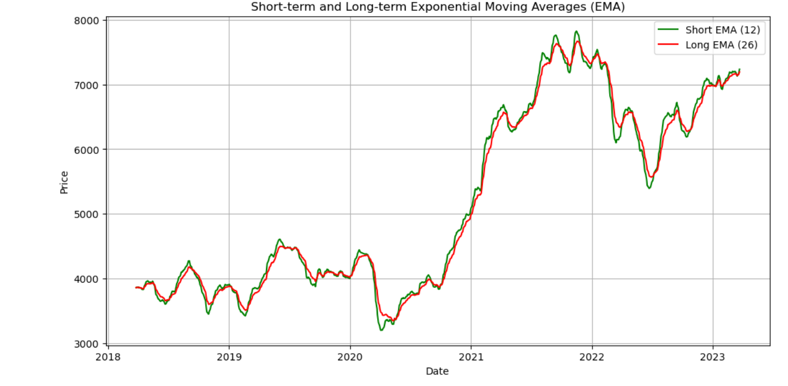

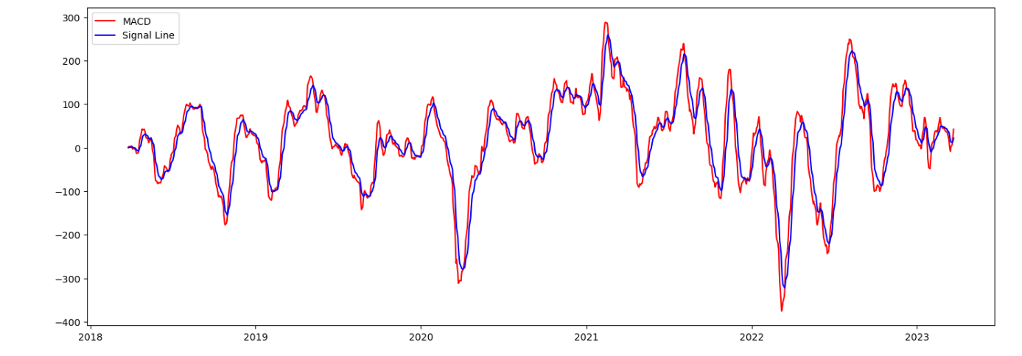

**MACD Histogram**

A MACD chart consists of three elements: the MACD line, a signal line, and a histogram, charted around a horizontal axis known as the baseline. The MACD chart is usually graphed just below the security's price chart, so that price movements can be compared with changes in the MACD chart.

The MACD line is calculated by subtracting a long-term exponential moving average (EMA) from a shorter-term exponential moving average. Generally, these are the twelve-day and 26-day EMA, calculated based on each day's closing price.

The signal line is calculated by taking the difference between the two EMAs, and from that number create a nine-day moving average.

Traders use the MACD histogram to identify potential trend reversals and price swings. When the histogram is positive (i.e., above the baseline) that means that the MACD is higher than its nine-day average, signifying a recent increase in upward momentum. When the histogram is below the baseline, the MACD is lower than its nine-day average.

Zeroes in the MACD histogram occur when the MACD line crosses higher than the signal line (generally considered a buy signal) or below the signal line (a sell signal). Peaks and troughs in the histogram indicate when a burst of bearish or bullish momentum is losing strength, and the curve is likely to return to its mean.

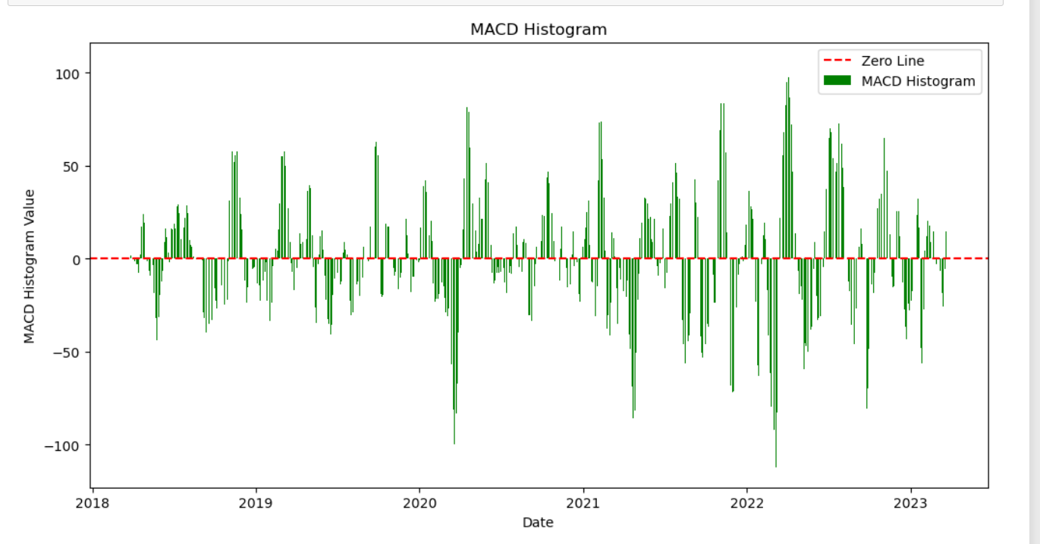

Calculating Graphs For PortFolio , Stock Return, Daily Return, Maximum Drawdown

Plot of Portfolio Returns

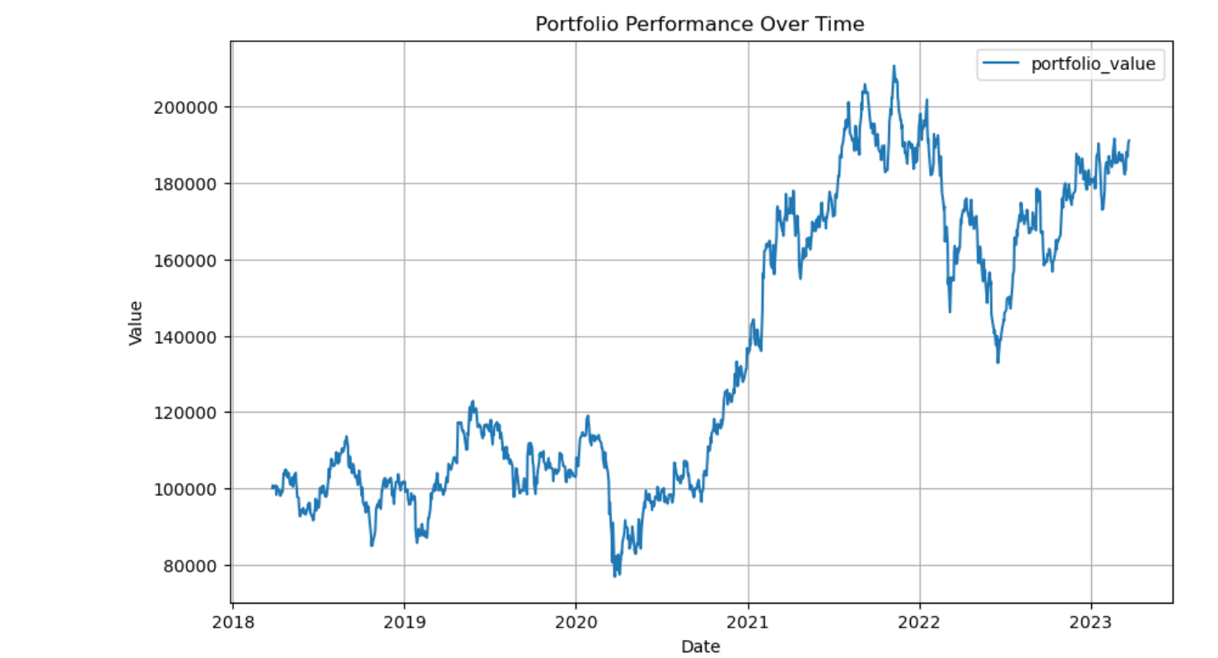

Plot of Stock Returns

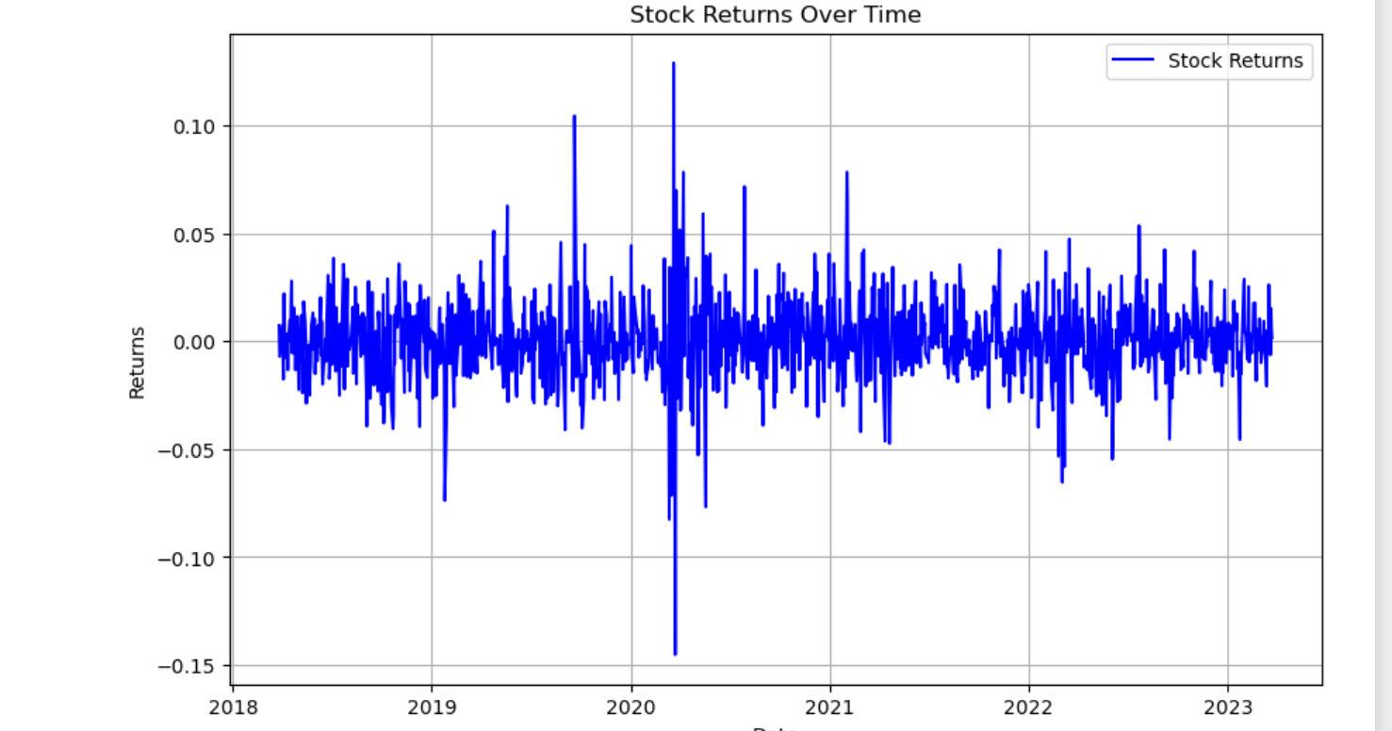

Plot of Daily Returns

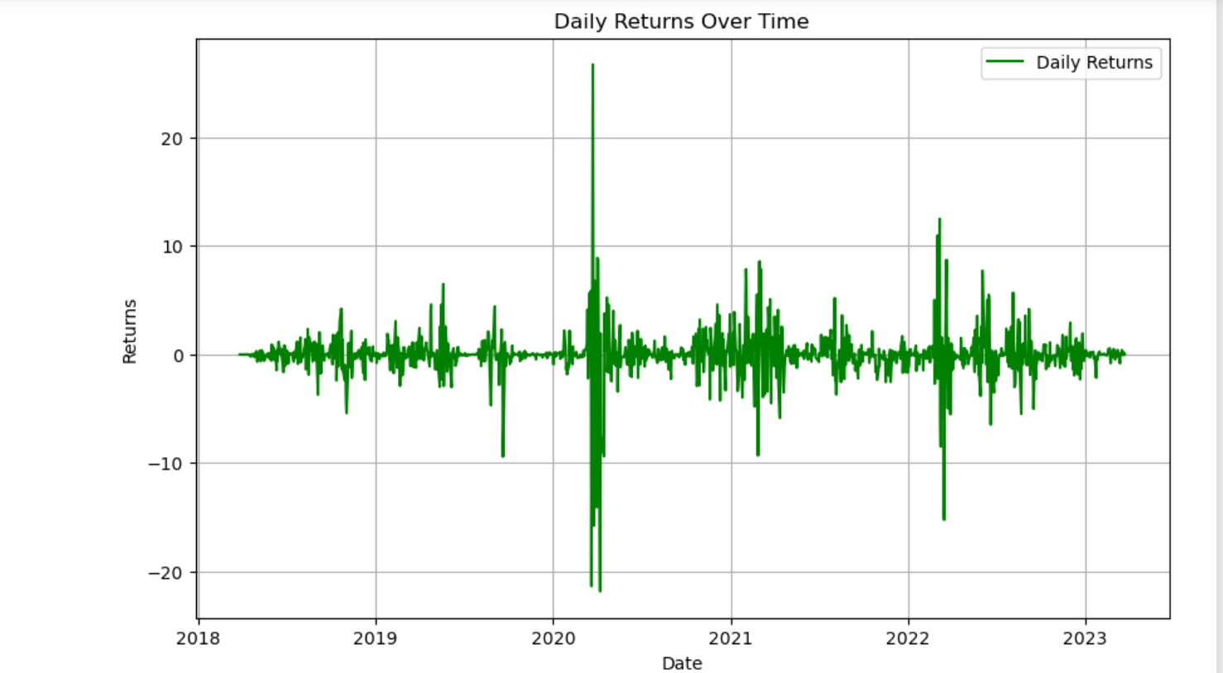

Plot of Maximum Drawdown

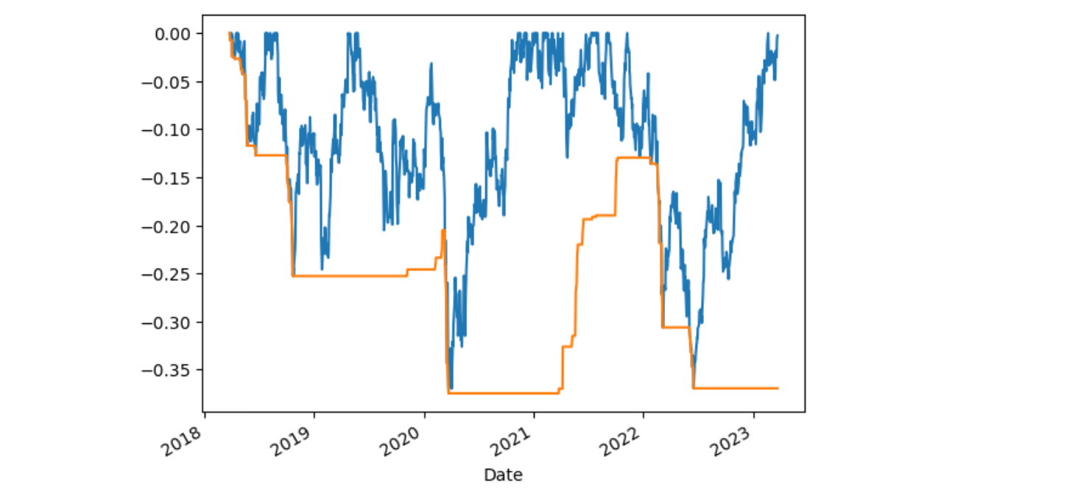

Scope for Improvement

* Lagging Indicator: MACD is a lagging indicator, which means it relies on past price data to generate signals. Traders may miss early trend reversals or price movements because MACD reacts after the fact. To improve this, traders can combine MACD with leading indicators like the Relative Strength Index (RSI) or stochastic oscillators to get a more comprehensive view of the market.
* Whipsaws: MACD generates signals, including crossovers between the MACD line and the signal line, which can result in false signals during choppy or sideways markets. To reduce whipsaws, traders can use additional filters, like moving averages, to confirm signals and reduce false entries.
* Limited in Ranging Markets: MACD is most effective in trending markets, but it may provide less useful information in ranging markets. In such situations, traders can look for additional indicators that are better suited for assessing range-bound conditions, such as Bollinger Bands.
* Backtesting is a critical component of evaluating the effectiveness of a MACD (Moving Average Convergence Divergence) strategy or any trading strategy
* Performance Assessment: Backtesting allows to assess the historical performance of your MACD strategy. You can see how the strategy would have performed in various market conditions, including different trending and ranging periods. This helps you gauge the strategy's potential profitability.
* Risk Management: Backtesting helps you evaluate risk management components of your strategy, such as stop-loss and take-profit levels. You can determine if your strategy adequately manages risk and capital allocation during different market scenarios.

**Indicators and Values Calculated**

• Annualised Return:- 150.91%

• Strategy Return:- 89.765%

• benchmark returns: 89.76

• Maximum Drawdown: -37.496310429399074 %

• Sharpe Ratio:- 0.34696

• Total number of trades: 1235

• Number of profitable trades: 587

• Number of losing trades: 647

• Win ratio: 0.475

• Largest profit making trade: 26.715895422290036

• Largest Loss-making Trade: -21.8287703346876

Link to Code:

<https://drive.google.com/file/d/1NSkBVfqi-9LOBfoVNHQpzYxuH9tXfAT6/view?usp=drive_link>

<https://drive.google.com/file/d/1EZhzTO0BLnWD_qTrvf3dxNUNseq-X1Oi/view?usp=drive_link>

Link to Csv file:

<https://drive.google.com/file/d/1qU7vzy5J5t2aEVM-vz9Ohlhws3UTdsW8/view?usp=drive_link>